tsewg tp-19: STATIC UNINTERRUPTIBLE POWER SUPPLY (ups)
Introduction
A static uninterruptible power supply (UPS) is used to provide stable power and minimize effects of electric power supply disturbances and variations. An UPS conditions incoming power and provides ride-through power for short-term outages and other voltage disturbances. For long duration outages, additional backup by an engine generator might be required. The UPS would provide the power while the engine generator is brought on-line. There are several types of UPSs on the market. This paper will primarily focus on double-conversion UPS type.

Several industry standards are available to assist with the selection and configuration of the UPS system. These include:

- IEC 62040-1 Uninterruptible power systems (UPS) – Part 1: General and safety requirements for UPS
- IEC 62040-3 Uninterruptible power systems (UPS) – Part 3: Method of specifying the performance and test requirements
- IEEE 241* Recommended Practice for Electrical Power Systems in Commercial Buildings (Gray book)
- IEEE 446* Recommended Practice for Emergency and Standby Power Systems for Industrial and Commercial Applications (Orange book)
- NEMA PE-1 Uninterruptible Power Systems (UPS) – Specification and Performance Verification
*Note that these are being replaced by IEEE 3000 Standards Collection

SELECTION AND PERFORMANCE
There are three basic UPS topologies:

- Standby UPS. A standby UPS allows the system to run off utility power until the UPS detects a problem, at which point the UPS switches to battery power to protect against sags, surges, or outages.

- Line-interactive UPSs. Line-interactive UPS regulate the incoming voltage by either boosting or bucking before allowing it to pass or use battery power to the protected equipment.

- Double-conversion UPS. A double-conversion UPS unit isolates the incoming power to the equipment by converting the incoming AC to DC (rectifying) and then converts the DC to AC (inverts). UFGS 26 33 53 Static Uninterruptible Power Supply (UPS) covers this type of UPS.

There are other topologies such as ferroresonant and rotary. Table 1 provides a summary of selected UPS designs.

Table 1 Performance of Selected UPS Designs

UPS Type | Power Reliability | Disturbance Suppression | Dynamic Response | Input Power Quality | Energy Efficiency
Off-Line | Fair | Fair | Fair | Excellent | Excellent
Double-Conversion | Excellent | Excellent | Excellent | Fair | Fair*
Line-Interactive | Very Good | Fair | Excellent | Very Good | Very Good
Rotary | Good | Good | Fair | Excellent | Fair
* New generation double conversion units can have economy-modes and transformer free technologies (which require special consideration for being served by the SAME input source), which will provide a higher level of energy efficiency.

An UPS consists of four major components:

- Converter (Rectifier)AC to DC rectifier/charger
- Inverter DC to AC
- Battery (10 yr. VRLA, 20 yr. VRLA, 20 yr. flooded)
- Static bypass switch

The converter can consist of 6-pulse, 12-pulse, IGBT, MOSFET, Delta Conversion, or Economy Mode. This is in order of development with 6-pulse the older technology and economy mode the newer. The converter takes the incoming AC and converts it to DC. It also provides the charging to the batteries in some systems.

The inverter can consist of 6-step, IGBT, MOSFET, or Economy Mode. Again, the older technology is indicated first. The inverter takes the DC and converts it to AC.

Batteries provide power to the load when there a disruption to the incoming voltage. Besides the type of battery to specify, the next most important item is how much battery time is required. Batteries are either a valve regulated lead acid (VRLA), or a wet cell (flooded). VRLA come in two main types: gel or absorbed glass mat (AGM). The AGM is the preferred type of the when used with an UPS system. Wet cells are still used, since they have a longer life, but have special installation requirements. Lithium-ION is an emerging technology with the UPS market, but currently is not allowed on military projects.

Static bypass switch. The static switch is there in case a component fails in the UPS module. When a failure is detected, the power is routed through the static switch bypassing the UPS module. This forms a second line of defense to help ensure power is maintained to the critical load. Static Bypass Switches come in two types: 1) Continuous Duty (most reliable) and 2) Momentary Duty (Older technology)

DESIGN CONSIDERATIONS
UFC Requirements

Refer to UFC 3-501-01, “Electrical Engineering” and UFC 3-520-01, "Interior Electrical Systems" for information. In addition, several UFCs discuss or have requirements pertaining to UPS Systems such as:

UFC 3-520-05 “Stationary Battery Areas”

UFC 3-530-01 “Interior and Exterior Lighting Systems and Controls”

UFC 3-535-01 "Visual Air Navigation Facilities"

UFC 3-540-01 “Engine Driven Generator Systems for Backup Power Applications”
UFC 3-540-08 “Utility-Scale Renewable Energy Systems”
UFC 3-580-01 "Telecommunications Building Cabling Systems Planning and Design"
UFC 3-600-01 “Fire Protection Engineering For Facilities”
UFC 4-021-01 “Design and O&M: Mass Notification Systems”
UFC 4-021-02 “Electronic Security Systems”
UFC 4-022-01 “Security Engineering: Entry Control Facilities/ Access Control Points”
UFC 4-133-01 “Air Traffic Control and Air Operations Facilities”
UFC 4-141-04 "Emergency Operations Center Planning and Design"
UFC 4-730-10 “Fire Stations”
Load Profile and Sizing
The UPS may exhibit load interface problems with certain types of ac load. The items which present the greatest problems are motors, transformers, electric discharge lighting, SCR, and mag-amp power supplies. Problems with these loads are caused by either load nonlinearity or inrush currents required for their operation. The UPS manufacturer will be better able to accommodate specific applications if well-defined load data is available. Additional considerations should include highly leading power factor loads (greater than .9PF leading), which can be seen in instances where HEMP filters are utilized.

The designer should carefully evaluate the UPS application to anticipate problems and to adjust the design accordingly. Designer needs to obtain the total continuous load, the load power factor, information on short-duration or momentary loads that need to be added to the continuous loads, and any inrush requirements.

The problems associated with UPS/load interaction can be reduced by some of the following approaches:

- Large Transformer Application

a. Using a transformer specifically designed for the transient specifications of the UPS.

b. Using a UPS with operating characteristics that will not cause the transformer to saturate.

- Motor Application

a. Using a UPS capable of providing motor inrush without current limiting.

b. Transferring the load bus to an alternate source (bypass) to start the motor and retransferring to the UPS after the motor has started.

c. Oversizing the UPS so the motor load represents a small portion of the UPS capacity.

d. Using a UPS with a modified inverter filter that is compatible with synchronous motors.

e. Ensure to provide series inductors on the input of variable frequency drive controllers.

- Nonlinear Loads

a. Using a UPS with a modified inverter filter.

b. Oversizing the UPS.

c. Avoiding connection of electric discharge lighting to the UPS.

UPS FORM FACTORs.
UPS’s come in considerable range of sizes and form factors. The various forms include: desktop and tower (typically smaller and single-phase configuration), rackmount (typically single-phase UPSs), scalable and large tower. The desktop/tower size are typically too small for double conversion type UPS. Data center and facility UPS typically range from 10 kVA to 1200 kVA.

Rackmount. Rackmount UPS will fit into a standard 19” rack found in a data center. Some rackmounts are also scalable. For smaller applications, 60 kW or less, this is an option.

Scalable. Scalable and modular UPS can be rack mounted or tower configurations. Rackmount will vary in size but typically the modules are around 10 kW. Towers are also scalable. The modules vary from manufacturer, but are typically around 250 kVA in size.

Large tower. Freestanding towers vary in size from the smaller 10 kVA to the larger 1200 kVA size. The larger rating is typically achieved by paralleling other modules of the same size. The upper end of a single tower is around 1200 kVA.

UPS Unit - INPUT CONFIGURATIONS
The following will discuss and show various input configurations for an UPS. In general, a maintenance bypass cabinet or panel is recommended. The more common maintenance bypass configurations are found in Figures 7, 8, and 9.

Single-Feed

This is the simplest configuration. It consists of one UPS feeder with both the UPS rectifier and static switch using the same feeder. No feeder externally bypasses the UPS. This has a single point of failure and to perform maintenance, the unit will require de-energizing. The input breaker will need to be sized to handle charging current in addition to the UPS load. This configuration is not recommended. See Figure 1.

Figure 1 Single-Feed UPS
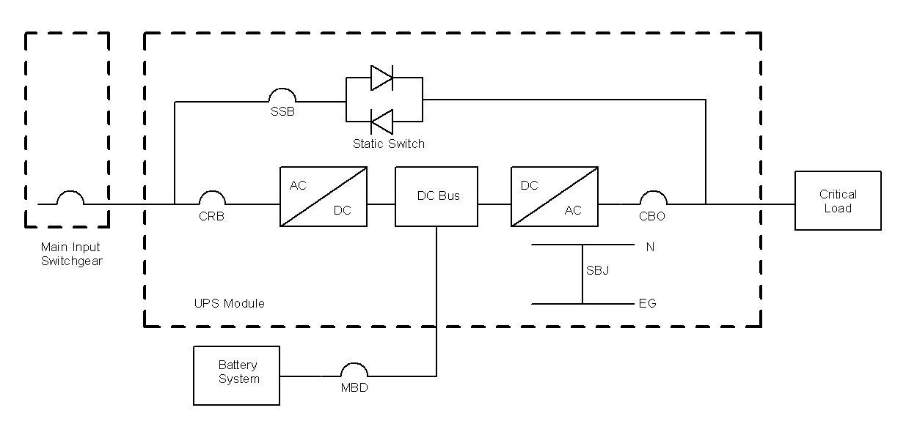

Legend:
SSB Static Switch Breaker (Disconnect)
CBR Circuit Breaker Rectifier
CBO Circuit Breaker Output
MBD Main Battery Disconnect
N Neutral
EG Equipment Ground
SBJ System Bonding Jumper

Dual-Feed

This configuration consists of a dedicated feeder to the UPS rectifier and one to the static switch. This is a better option than the single-feed. However, with arc-flash requirements, maintenance on the UPS unit will be problematic and most likely will require both feeders to be de-energized. Most UPS systems have the static switch internal to the UPS as shown, except in very large configurations, which is discussed later. The input breaker that power the rectifier will need to be sized to handle charging current in addition to the UPS load. See Figure 2.

Figure 2 Dual-Feed UPS
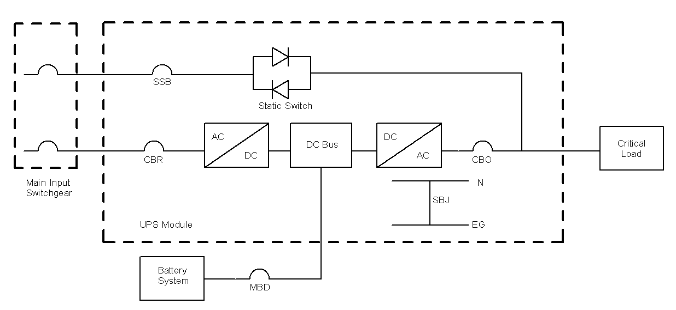
Legend:
SSB Static Switch Breaker (Disconnect)
CBR Circuit Breaker Rectifier
CBO Circuit Breaker Output
MBD Main Battery Disconnect
N Neutral
EG Equipment Ground
SBJ System Bonding Jumper

External MAINTENANCE BYPASS CONFIGURATIONS.
There are several configurations available for an external maintenance bypass cabinet/panel. It is strongly recommended that an external maintenance bypass be provided, unless indicated otherwise by the customer. The external maintenance bypass allows the UPS to be taken out of service, while still maintaining power to the critical load. The following will show some of the more common configurations. It is important to note the number of breakers in the maintenance bypass cabinet and the number of input feeder breakers in each configuration. The larger the sum of breakers, the better the ability to ensure the load will maintain power; however, the higher number of breakers may not be the automatic solution. It is important to consider cost, maintenance, and switching complexity for each application. The configurations shown do not have a transformer. If there is a transformer, then one must be careful to ensure the connection points have the correct voltage. It is recommended, when possible, to have two input feeders and at least a two breaker bypass cabinet such as is shown in Figure 5. If two input breakers are not possible, then consider Figures 7 or 9.

Two-Breaker External Bypass Panel

The two-breaker external bypass panel consists of one breaker that is fed from the UPS output and another breaker that is powered by a separate dedicated feeder. The output of each is to a common bus, which powers the load. This configuration is considered to have three breakers. The input breaker will need to be sized to handle charging current in addition to the UPS load. The interlock typically consists of a Kirk Key system and it used to ensure that ‘make before break’ transfer to external maintenance bypass is accomplished within the UPS by the internal static switch bypass mode. See Figure 3.

Figure 3 Two-Breaker External Bypass Configuration

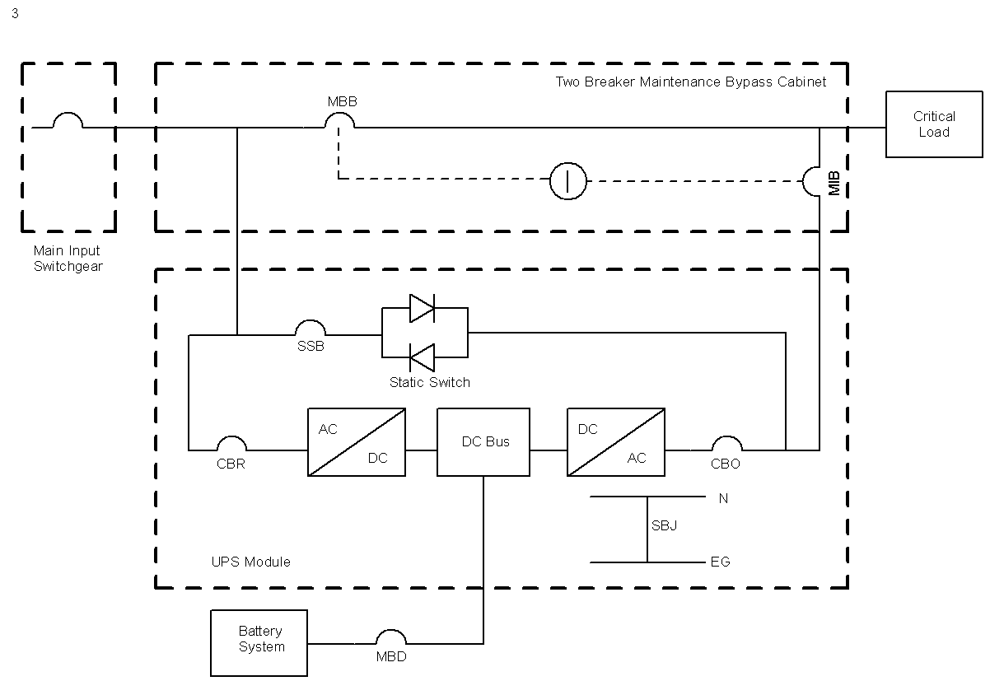
Legend:
MBB Maintenance Bypass Breaker
MIB Maintenance Isolation Breaker
SSB Static Switch Breaker (Disconnect)
CBR Circuit Breaker Rectifier
CBO Circuit Breaker Output
MBD Main Battery Disconnect
N Neutral
EG Equipment Ground
SBJ System Bonding Jumper
Interlock

Two-Breaker External Bypass Panel with Dual-Feed to UPS: Four Breakers

The UPS has a two input feeders and a two-breaker bypass panel. This configuration is considered to have three breakers. There are different variations that can be used and specified. The input breaker that powers the rectifier will need to be sized to handle charging current in addition to the UPS load. The interlock typically consists of a Kirk Key system and it used to ensure that ‘make before break’ transfer to external maintenance bypass is accomplished within the UPS by the internal static switch bypass mode. See Figures 4, 5, and 6. Figures 4 and 5 are the more common configurations for a two-breaker external bypass cabinet.

Figure 4 Two-Breaker External Bypass with Dual-Feed – Variation 1
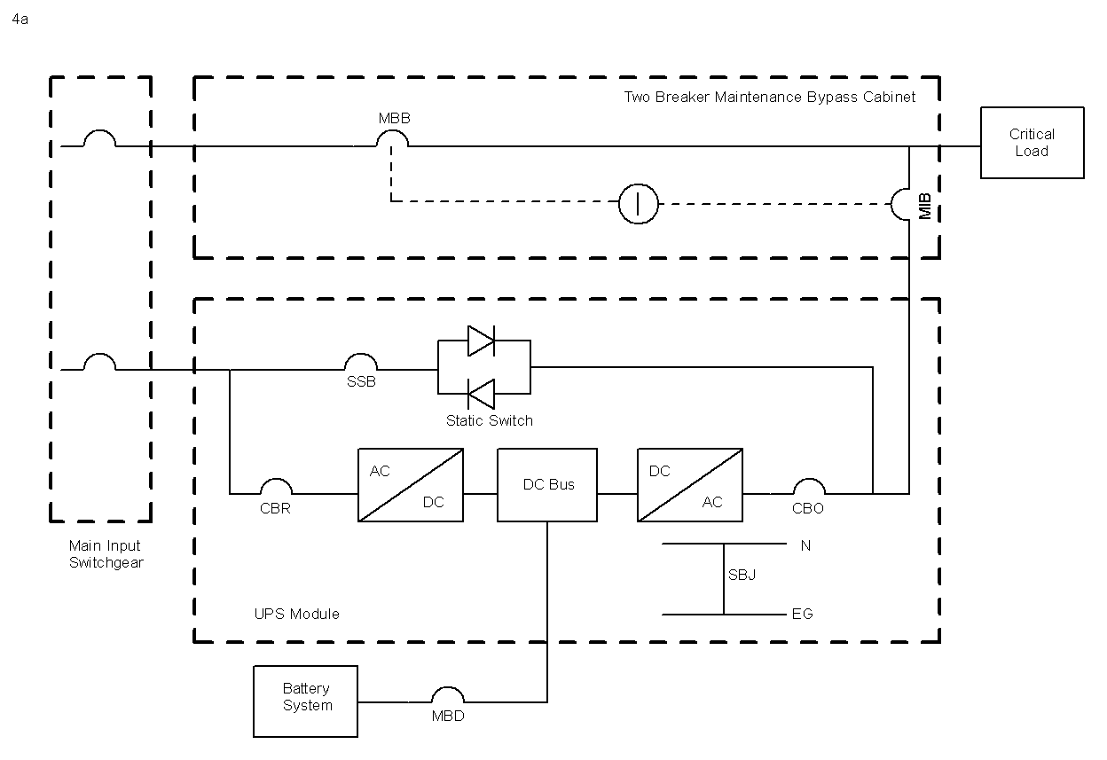
Legend:
MBB Maintenance Bypass Breaker
MIB Maintenance Isolation Breaker
SSB Static Switch Breaker (Disconnect)
CBR Circuit Breaker Rectifier
CBO Circuit Breaker Output
MBD Main Battery Disconnect
N Neutral
EG Equipment Ground
SBJ System Bonding Jumper
Interlock

Figure 5 Two-Breaker External Bypass with Dual-Feed – Variation 2
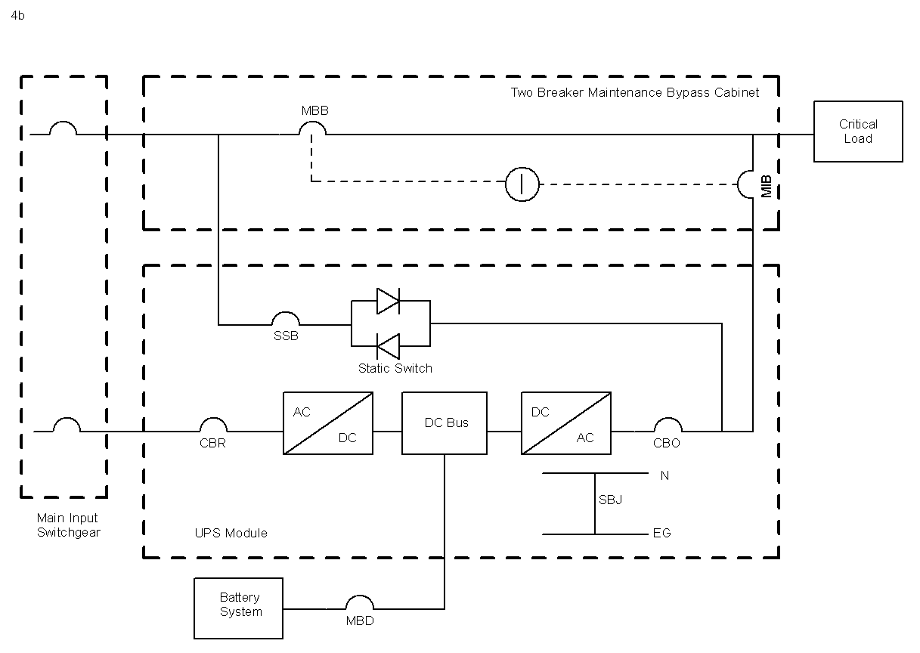
Legend:
MBB Maintenance Bypass Breaker
MIB Maintenance Isolation Breaker
SSB Static Switch Breaker (Disconnect)
CBR Circuit Breaker Rectifier
CBO Circuit Breaker Output
MBD Main Battery Disconnect
N Neutral
EG Equipment Ground
SBJ System Bonding Jumper
Interlock

Figure 6 Two-Breaker External Bypass with Dual-Feed – Variation 3

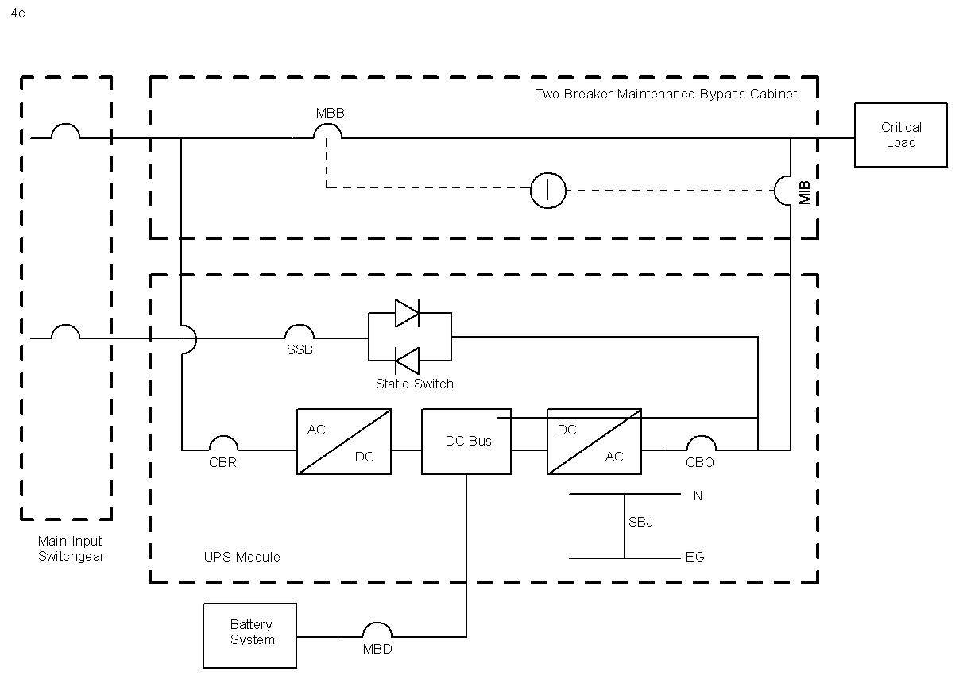
Legend:
MBB Maintenance Bypass Breaker
MIB Maintenance Isolation Breaker
SSB Static Switch Breaker (Disconnect)
CBR Circuit Breaker Rectifier
CBO Circuit Breaker Output
MBD Main Battery Disconnect
N Neutral
EG Equipment Ground
SBJ System Bonding Jumper
Interlock

Three-Breaker External Bypass Panel with Single-Feed to UPS: Four Breakers

The UPS has a one input feeder and a three-breaker bypass panel. This configuration is considered to have four breakers. The input breaker that powers the rectifier will need to be sized to handle charging current in addition to the UPS load. The interlock typically consists of a Kirk Key system and it used to ensure that ‘make before break’ transfer to external maintenance bypass is accomplished within the UPS by the internal static switch bypass mode. See Figure 7.

Figure 7 Three-Breaker External Bypass with Single-Feed
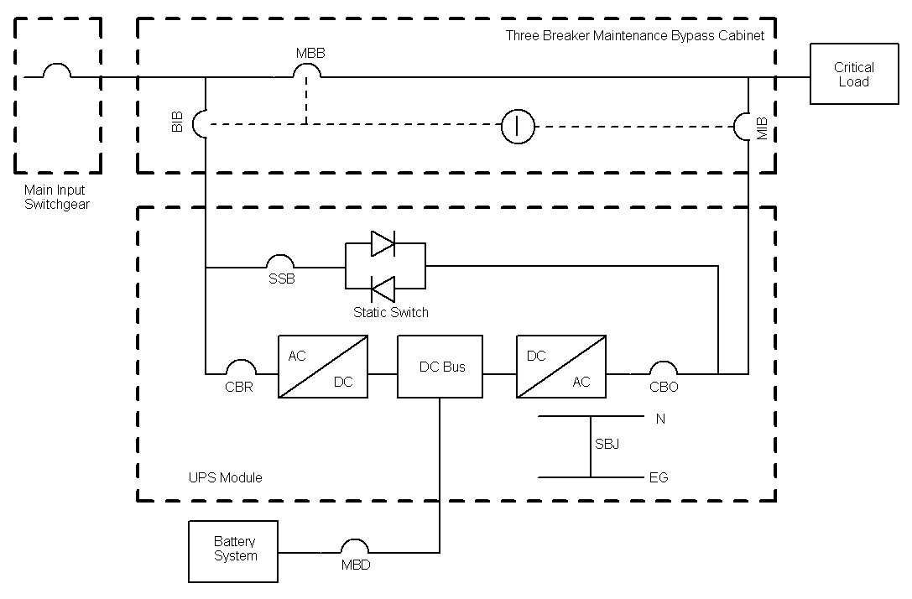
Legend:
MBB Maintenance Bypass Breaker
MIB Maintenance Isolation Breaker
SSB Static Switch Breaker (Disconnect)
CBR Circuit Breaker Rectifier
CBO Circuit Breaker Output
MBD Main Battery Disconnect
N Neutral
EG Equipment Ground
SBJ System Bonding Jumper
Interlock

Three-Breaker External Bypass Panel with Dual-Feed to UPS: Five Breakers

The UPS has a two input feeders and a three-breaker bypass panel. This configuration is considered to have five breakers. This is considered the best in maintaining power to the critical load and for being able to isolate the various components, but it does increase the switching complexity. The input breaker that powers the rectifier will need to be sized to handle charging current in addition to the UPS load. The interlock typically consists of a Kirk Key system and it used to ensure that ‘make before break’ transfer to external maintenance bypass is accomplished within the UPS by the internal static switch bypass mode. See Figure 8.

Figure 8 Three-Breaker External Bypass with Dual-Feed

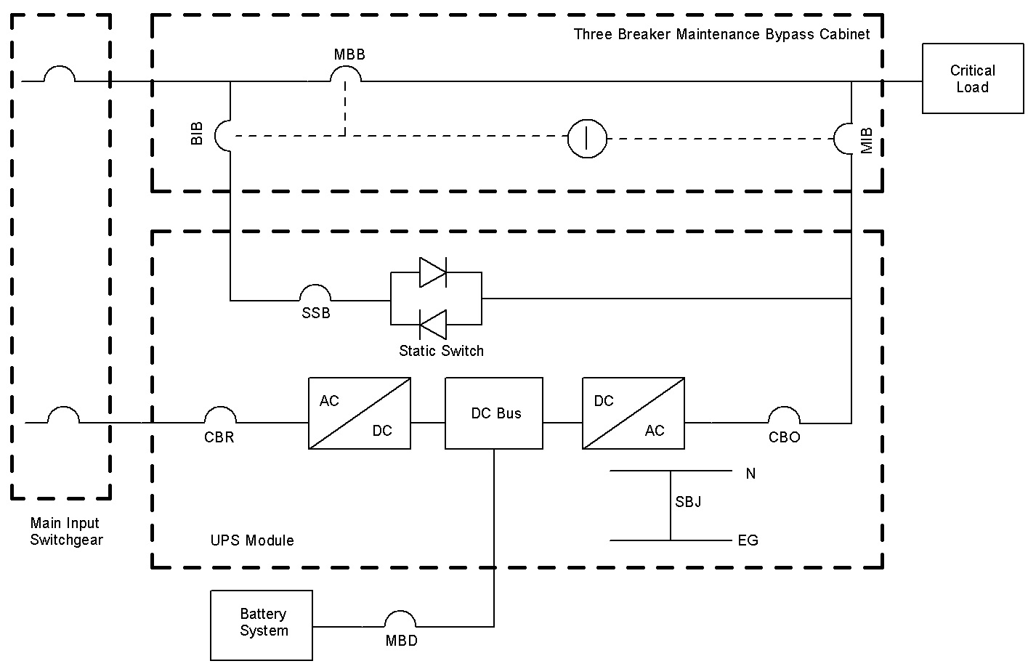

Legend:
MBB Maintenance Bypass Breaker
MIB Maintenance Isolation Breaker
BIB Bypass Input Breaker
SSB Static Switch Breaker (Disconnect)
CBR Circuit Breaker Rectifier
CBO Circuit Breaker Output
MBD Main Battery Disconnect
N Neutral
EG Equipment Ground
SBJ System Bonding Jumper
Interlock

Four-Breaker External Bypass Panel with Single-Feed to UPS: Five Breakers

The UPS has a one input feeder and a four-breaker bypass panel. This configuration is considered to have five breakers. This may have five breakers, but it only has a single-feed. The input breaker that powers the rectifier will need to be sized to handle charging current in addition to the UPS load. The interlock typically consists of a Kirk Key system and it used to ensure that ‘make before break’ transfer to external maintenance bypass is accomplished within the UPS by the internal static switch bypass mode. This configuration is not recommended. See Figure 9.

Figure 9 Four-Breaker External Bypass with Single-Feed

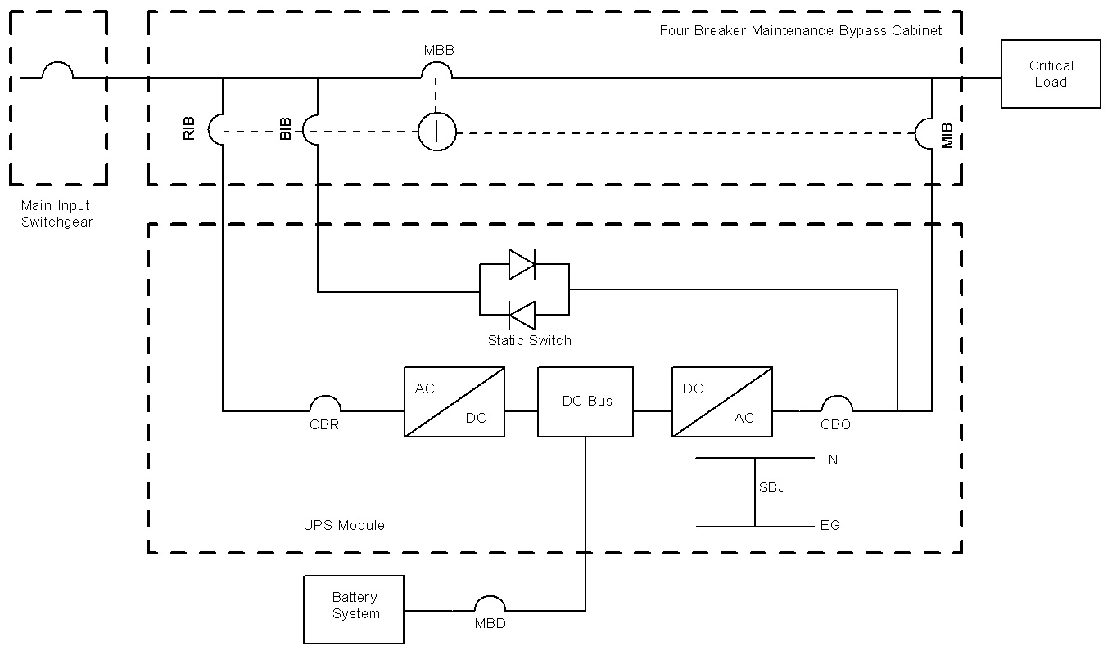

Legend:
MBB Maintenance Bypass Breaker
MIB Maintenance Isolation Breaker
BIB Bypass Input Breaker
RIB Rectifier Input Breaker
SSB Static Switch Breaker (Disconnect)
CBR Circuit Breaker Rectifier
CBO Circuit Breaker Output
MBD Main Battery Disconnect
N Neutral
EG Equipment Ground
SBJ System Bonding Jumper
Interlock

Two-Breaker External Bypass Panel with Triple-Feed to UPS: Five Breakers

This is a variation on the two-breaker bypass panel previously shown, but with three input breakers. The input breaker that powers the rectifier will need to be sized to handle charging current in addition to the UPS load. The interlock typically consists of a Kirk Key system and it used to ensure that ‘make before break’ transfer to external maintenance bypass is accomplished within the UPS by the internal static switch bypass mode. This is a five-breaker configuration. See Figure 10.

Figure 10 Two-Breaker External Bypass with Triple-Feed

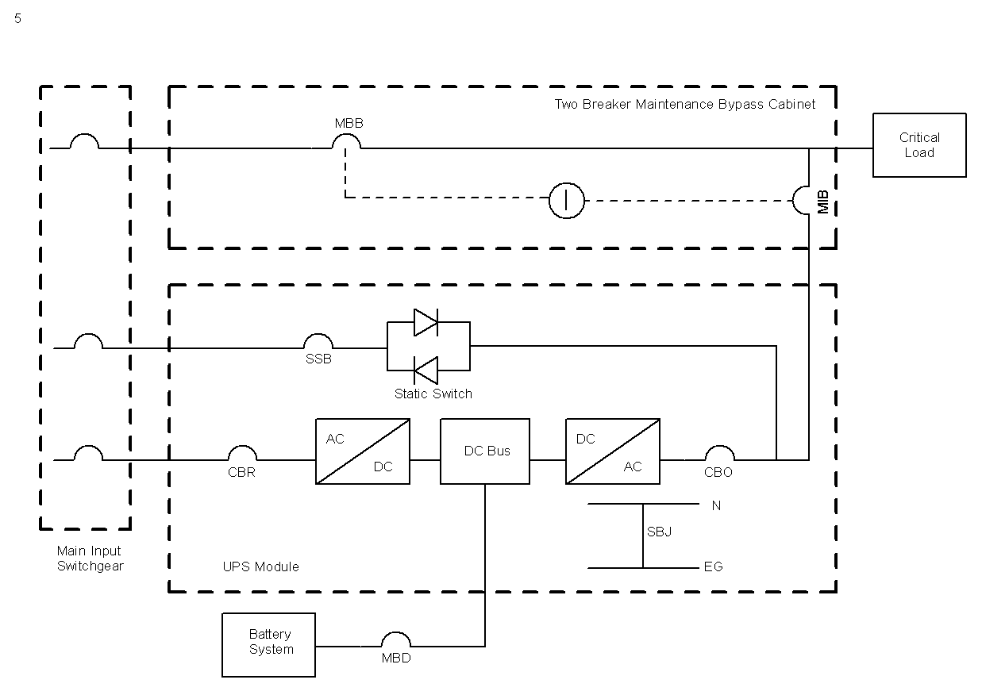

Legend:
MBB Maintenance Bypass Breaker
MIB Maintenance Isolation Breaker
SSB Static Switch Breaker (Disconnect)
CBR Circuit Breaker Rectifier
CBO Circuit Breaker Output
MBD Main Battery Disconnect
N Neutral
EG Equipment Ground
SBJ System Bonding Jumper
Interlock

UPS Unit – parallel CONFIGURATIONS
UPS units or modules can be paralleled in various configurations to form a single system. There are different methods that can be used to parallel units: automatic transfer switch (not done very often), paralleling cabinet, making one UPS a master controller, or each monitoring the incoming voltage independently. Paralleling can be done for extra capacity or redundancy. In an N+1 configuration, there is an extra UPS module whose capacity could carry the entire load. Scalable expandable units can easily add another level of redundancy by having a power module within a UPS unit that is redundant. However, this configuration is not a true N+1 configuration since only partial redundancy is obtained i.e. a true redundant UPS with the same capacity is not provided.

The isolated redundant configuration or sometimes called a hot standby system, uses the static switch bypass of the primary to tie the output of the secondary UPS to the critical load. The advantage to this configuration is that there is a second unit to carry the load when the primary fails to operate, maintenance on a single unit allows power to the critical load, no control wiring between the modules, and the units do not have to be the same make and model. The mean time between failures is higher than the mean time between failures for a single module. Some of the disadvantages consist of no load sharing between the two units, there are many single points of failure, the second UPS has to be able to handle a large load step, and overload capacity is limited to the static switch rating. See Figure 11.

Figure 11 Isolated Redundant
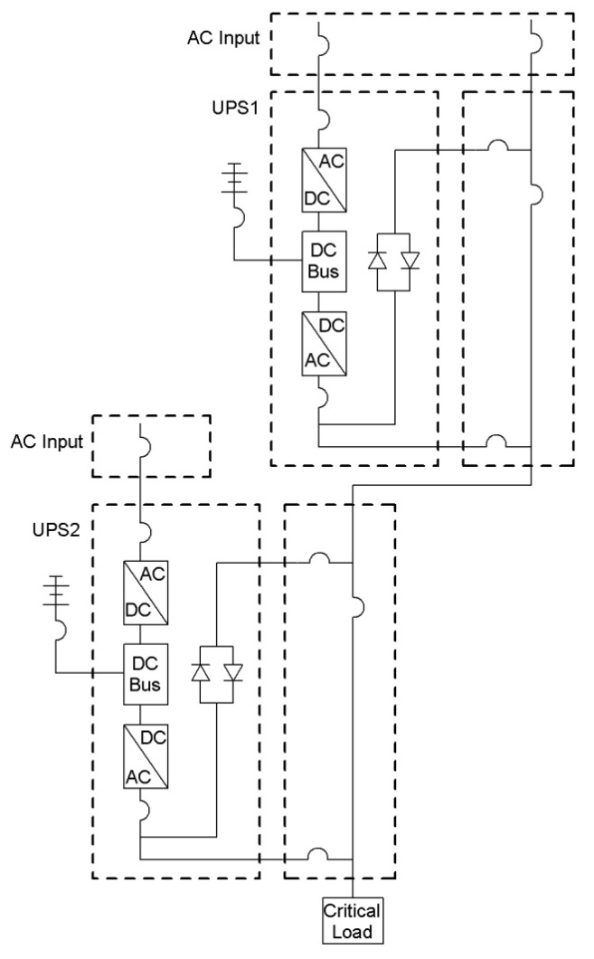

A distributed bypass system is where each UPS module has a static switch. This configuration can be setup to be a 1+N configuration, so when one module goes down the remaining module or modules can pick up the load. The advantages to this configuration is that there is another unit to carry the load when one fails to operate, maintenance on a single unit allows power to the critical load, there is load sharing between the modules, and work can be performed on a static switch without impacting power to the critical load. The mean time between failures is higher than the mean time between failures for a single module. This system tends to be cheaper when compared to the central bypass system. Disadvantages are that the modules must be identical, conductor impedance to the static switch must be nearly the same (conductor lengths must be nearly identical), and the static switches must operate in unison. Figure 12 shows a typical configuration. It is important to have enough input and output breakers to be able to isolate each UPS from the system. Note the downstream paralleling / maintenance bypass switchgear should have the MIB (Maintenance Isolation Breaker) and the MBB (Maintenance Bypass Breaker) up-sized for the redundancy design. If the design is an N+1 the MIB and MBB will be sized to support two UPSs on-line with one standby. If the design is an N+0 where all three UPSs are sized to support the critical load the MIB and MBB will need to be up-sized accordingly. It is often best to provide the up-sizing of the External Maintenance Bypass to accommodate three modules for capacity, since the load only requires One or two modules to support the load the system will inherently have one or two modules available for redundancy.

In a distributed bypass system, when one static switch fails to operate, the rest of the switches still function and can support the load. However, if the distributed bypass system does not have redundancy and is fully loaded, then a static switch open-circuit failure will lead to an unavailable bypass. The following is a description on how the system will behave when there is redundancy.

- Normal transfer to bypass. Under a distributed bypass system when one of the UPS is commanded to bypass or is caused to bypass (overheating, overload or similar), then the system will go to bypass. At the same time, the UPS transmits a transfer request to the other units over the communication line. The transfer of the other units will take place in about 2 milliseconds.

- Emergency transfer to bypass. Emergency transfer to bypass typically happens with the inverters are not capable of maintaining the system output voltage in normal limits. The probable cause is a short circuit in the output and the inverters are feeding as much current to the fault as possible to maintain the output voltage and can possibly reach their current limit. If the downstream protective devices aren’t small enough or fast enough, the UPS system output voltage will drop and go out of limits. This causes an emergency transfer to bypass resulting in high level of fault current through the bypass to clear the fault. The problem is each unit is monitoring the situation and will transfer independently. Normally the detection happens with all units detecting at approximately the same time, so the fault current then ends up being shared by the static switches. If not, then one static switch may end up with most of the fault current.

Figure 12 Distributed Bypass System

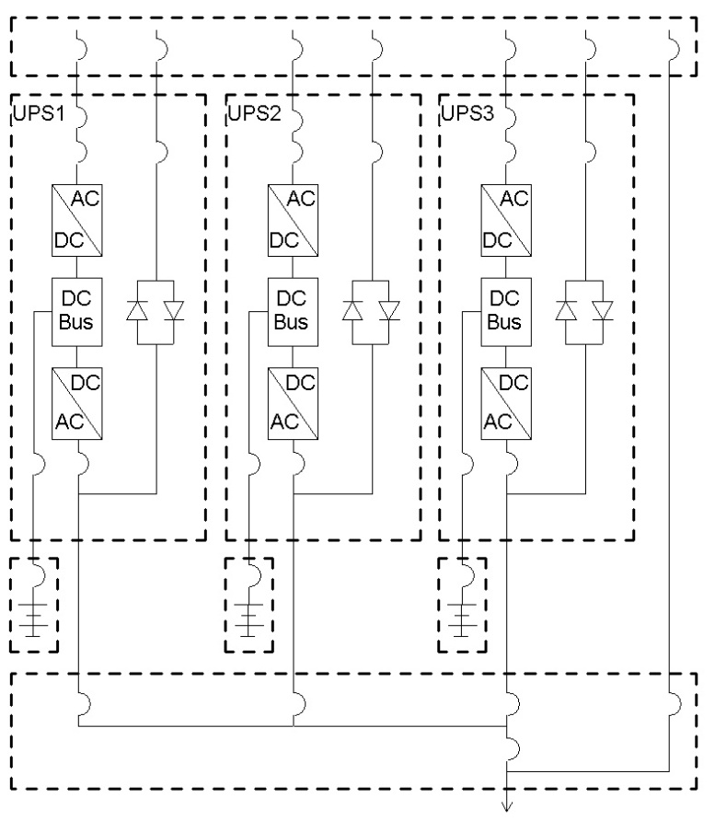

A centralized bypass system is where the UPS system has a single static switch i.e. the UPS modules do not have individual static bypass switches. This configuration can be setup to be an N+1 configuration, where if one module goes down the remaining module or modules can pick up the load. The advantage for this system is that there is another unit (static bypass switch) to carry the load when one fails to operate, maintenance on a single unit allows power to the critical load, there is load sharing between the modules, installation is not impacted by cable length differences, and has less components that could fail. Work can be performed on the static switch module/cabinet without impacting power to the critical load. The mean time between failures is higher than the mean time between failures for a single module. The static switch must be sized to handle the entire system. Another advantage is that the Central Bypass System offers 575V or 600V applications to be used. The use of 575V and 600V will significantly lower the Ampacity ratings needed for the breakers and allow the system to provide more kW to support larger loads. The disadvantages include dependence on a single static switch, dependence on a single bypass breaker, and maintenance costs are normally higher. See Figure 13.

Figure 13 Centralized Bypass System

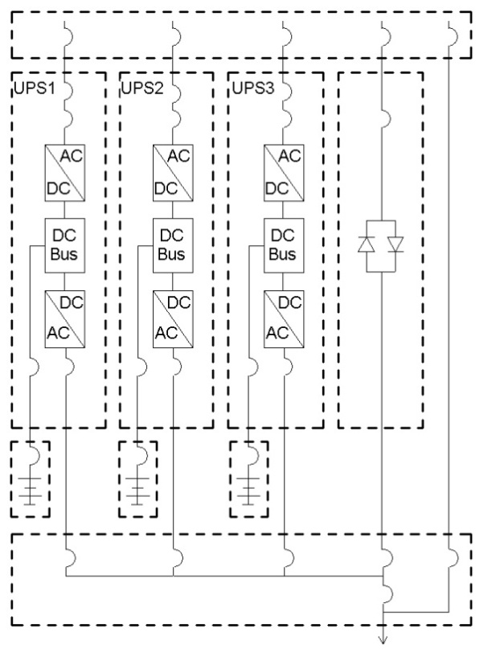

COMPARING TRANSFORMERLESS TO TRANSFORMER UPS DESIGNS

In general, the industry is going to transformerless UPS designs. This approach helps improve efficiency, simplifies the UPS module, smaller footprint, less weight, and reduces cost.

Transformer based UPS module, see Figure 14. A transformer based UPS module will have a passive filter ahead of the rectifier input to reduce input current distortion. There may be an optional input isolation transformer to provide AC-DC isolation. Normally the isolation transformer is on the inverter output to derive the output voltage followed by another passive filter, but this will vary with manufacturer. The isolation transformer normally does not provide voltage transformation. If voltage transformation is required, this can be accomplished with a transformer that is part of the UPS or an external transformer. In either case, be sure to ensure the maintenance bypass is providing the correct voltage. The isolation transformer provides a solid point for bonding the supply side bonding jumper. Transformer style UPS will normally have a higher impedance, which will reduce the available fault current, though there are other factors that determine the arc-flash value. Another advantage to transformer based UPS systems is UPS modules can easily be fed from different / separately derived electrical sources one from an “A” source one a “B” source. NOTE: The bypass source will always be common, which is what the inverter from the UPS modules always track.

Another advantage to transformer based UPS systems is UPS modules can easily be fed from different / separately derived electrical sources (one from an “A” source one a “B” source. NOTE: The bypass source will always be common, which is what the inverter from the UPS modules always track.)

Rectifiers consist of a silicon controlled rectifier (SCR) or insulated gate bipolar transistor (IGBT) components. SCRs can either be 12 pulse or 6 pulse. The 6 pulse has higher total harmonic distortion than the 12 pulse and is not recommended. The 12 pulse does require the input isolation transformer, while the 6 pulse it is optional. NOTE: Make sure that the input isolation is a full input isolation transformer and not a half input isolation transformer). An IGBT style rectifier using pulse width modulation (PWM) has limited need for filters and is common in transformerless UPS modules.

Transformerless UPS use more solid-state electronics instead of the isolation transformers. The input will not require a transformer and special filtering, but will use PWM IGBT technology for the rectifier/charger. The batteries will likely be connected to the DC bus through a DC to DC converter, so there is an additional component. The output will not have the output transformer, but otherwise will have the same components shown in the transformer based configuration. Most transformerless UPS are three-wire in and three-wire out, so a transformer may be needed to establish the neutral. Transformer-less UPSs generally require that the external maintenance bypass and the UPS bypass and rectifier Inputs are fed from the same source.

Exterior transformers may still be required on either the input or the output, but are not part of the UPS module. The transformers may be used for AC to DC isolation, increase safety, voltage transformation, or increased flexibility.

Figure 14 Transformer UPS Configuration
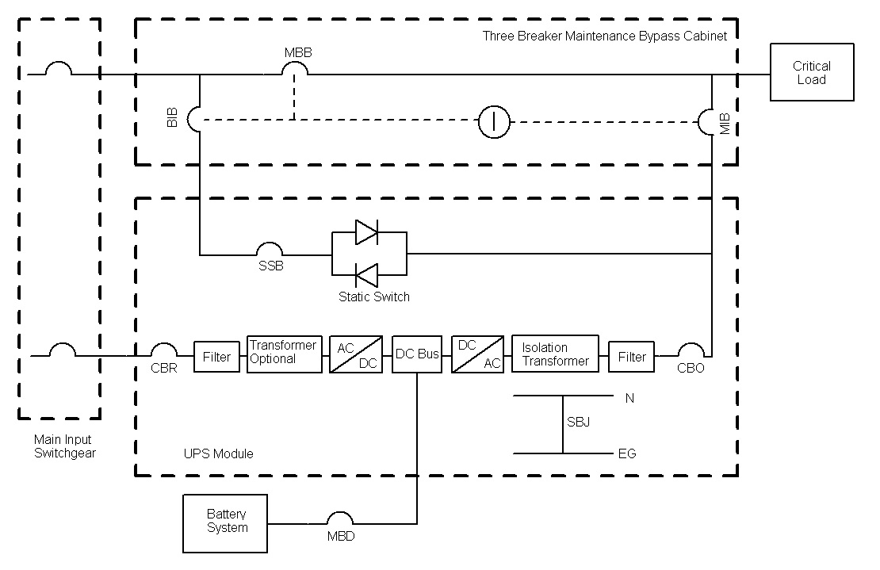

GENERTOR AND UPS

The UPS slew rate (change in frequency per unit of time at the output of the generator) is very important when the module/unit can be powered at times from a generator. Normally the utility frequency is very stable, but when a generator comes on-line, the generator frequency can fluctuate. The UPS will reject the generator as a source and remain on battery until the frequency is stabilized.

Other factors concern the UPS passive filters. The input passive filter can force the UPS input current to a leading power factor when the UPS is lightly loaded (less than 40%). Most UPS manufacturers offer options to handle this possibility. If the UPS is operating at over 10% total harmonic content (not recommended), then the generator may need to be derated.

UPS and generator must be coordinated to ensure both will operate properly. The generator must also be able to operate with the UPS operating in bypass mode. The UPS should monitor when it is on generator power (normally via a dry contact) in order to reduce the charging current to the batteries. This will cause the UPS to be a lighter load to the generator. Special consideration needs to be taken to the location of the automatic transfer switch as the “dry contact” wiring may be many feet away from the UPS room. Information on the drawings will need to reflect that this “dry contact” wing is needed for the “on generator” signal to be known by the UPS module(s). Otherwise the generator must be sized to handle the charging current to the batteries.

SURGE PROTECTION AND POWER FILTERING

Double-conversion UPS operating under normal conditions process power through the rectifier/charger (AC to DC) and then through the inverter (DC to AC) to prevent damaging input conditions from passing through the UPS to the critical load. If the UPS in operating in bypass, then damaging impulses can get to the critical load, so surge protection may be still be required. Energy saving modes typically bypass the double-conversion in order to improve efficiency i.e. facility power is used. If the UPS is being used to filter the incoming power, then it is not recommended that this type of energy saving mode be used.

INFORMATION TECHNOLOGY (IT) EQUIPMENT ON UPS

IT equipment power supplies are designed to store energy for about 20 milliseconds (ms) during a power interruption. This is known as the “hold-up” time. The longer the power supply goes without power, the higher in the inrush will be when power is restored. In double-conversion UPS units, the UPS will begin drawing current from the batteries with zero interruption. However, if the UPS unit has and is operating in an energy saving mode, there will be some transfer time to battery. This time is still short, 1-3 milliseconds, which will keep the inrush to less than 200 percent of normal peak currents. The UPS unit may take longer than the 1-3 milliseconds when a transformer is present. In those cases, the transfer time can be four times longer. This longer time is not recommended if IT equipment is part of the critical load. If an UPS is designed to have energy saving “Eco-Mode”, it is often prudent to consider adding in a storm detection system that will take the UPS off “Eco-Mode” and switch to double conversion mode when a storm is in the area.

TRANSFER SWITCHES

It is not uncommon for facilities that have an UPS to have more than one power source. This can be a generator or other power source. The switching between the primary and secondary sources can be done by an automatic transfer switch or a manual switch. A more complete discussion on transfer switches is found in TSEWG TP-09 Automatic Transfer Equipment.

Switching that uses a 3-pole device (manual or automatic) will interrupt the phases, but does not interrupt the neutral. The neutral between the primary and secondary sources are tied together, so that circulating currents can occur between the sources. See Figure 15 for a typical 3-pole plus solid neutral diagram. Note: If the neutrals are not grounded at the same point, there can be a voltage differential between them which could cause current flow during the overlap. This could cause problems with the secondary power source including a generator.

Figure 15 Three-pole Transfer Switch Configuration

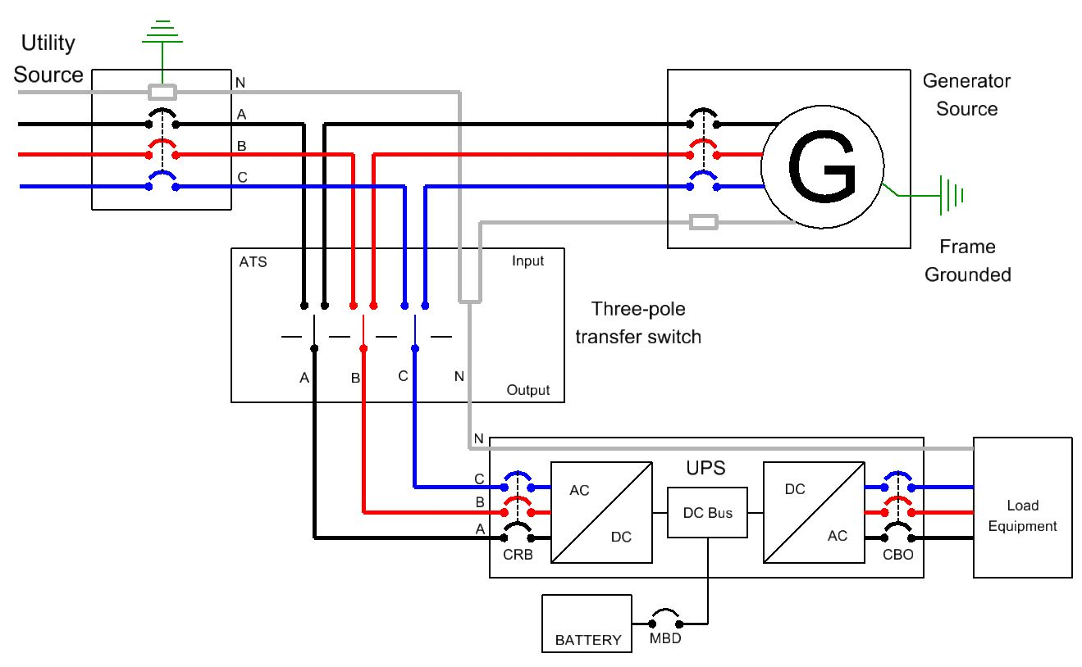

Automatic switching that uses a 4-pole device interrupts the phases and the neutral. See Figure 16 for a typical 4-pole diagram. There are different ways that the switching can take place.

- Overlapping Neutral. The neutral between the two sources will overlap in a make-before-break fashion even though the phases are operated in a break-before make fashion. This method ensure the UPS has a constant neutral for return currents and for reference source. Note: If the neutrals are not grounded at the same point, there can be a voltage differential between them which could cause current flow during the overlap. This may cause problems with the secondary power source that consists of a generator.

- Break-Before-Make. The neutral and the phases between the power sources will break-before-make. This is called an open transition. The two sources included the neutral are completely isolated from each other at all times. This configuration is important when one or both sources have ground fault protection. UPS manufacturers’ for a specific type of UPS may recommend the break be at least 50 ms.

- Make-Before-Break. The neutral between the power sources and the phases will make-before-break. This momentarily ties the two power sources together and is called a closed transition. The switch logic must determine if both source voltages, frequencies and the phase relationship are within acceptable limits. This approach can help limit inrush currents caused by motors, transformer, and high intensity discharge lighting. The local utility will typically have to be consulted and give approval. This configuration is not common practice. UPS manufacturers’, for specific type of UPS, may recommend that the make be at least 50 ms.

- Solid Neutral. A jumper wire is used to connect the neutrals together to convert the device a three-pole device plus solid neutral.

Figure 16 Four-pole Transfer Switch Configuration

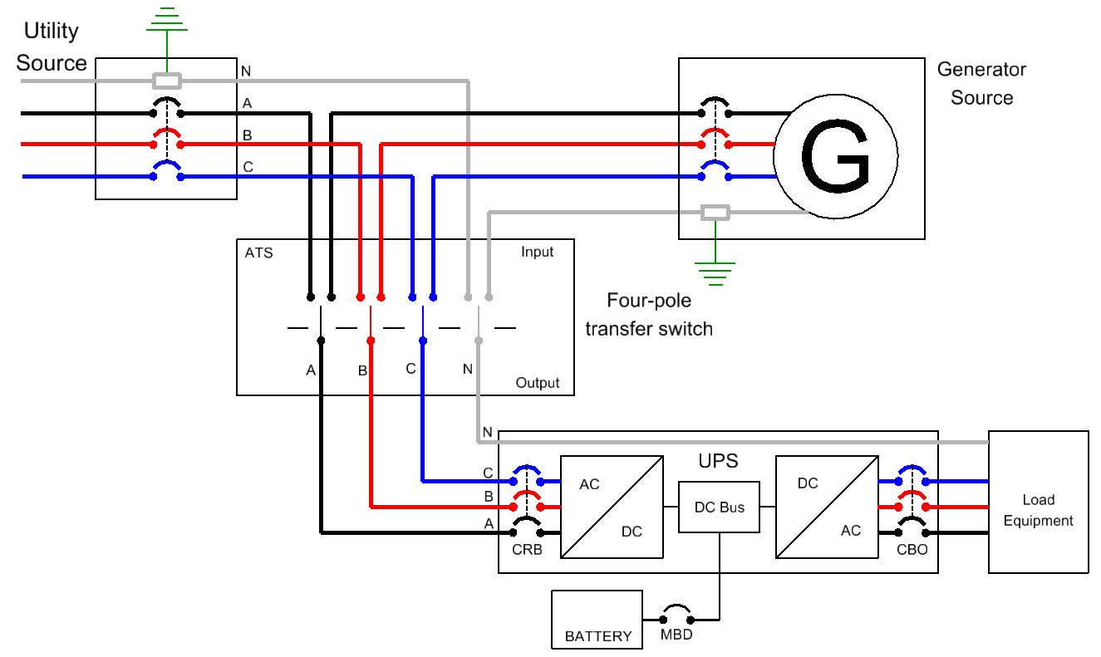

TRANSFORMERLESS UPS AND NEUTRAL

Majority of UPS configurations are now transformerless. A transformerless UPS does not use either an input or output transformer for isolation or voltage conversion. Some transformerless configurations still do have an option to have an isolation transformer, in which case the isolation transformer will create a neutral, but there are fewer models with this option. IMPORTANT: A transformerless UPS is not considered a separately derived source as defined by the National Electrical Code.

Not having a transformer requires discussion on what to do with the neutral and the potential design impacts. These issues are listed below:

- A transformerless UPS can generate their own output neutral when on inverter. However, this does not make it a separately derived system. There still isn’t electrical isolation between the systems.

- The UPS typically does not generate a neutral when on by-pass, so the source neutral must be brought through the UPS to the critical load.

- In addition, some manufactured UPS units, those that have are 400 kVA and smaller, may require the neutral to not be broken to the critical load. This is accomplished by either having a solid neutral in the transfer switch, or by a make-before-break switching action on the neutral in the transfer switch or by installing a transformer either before the UPS or after the UPS. If a transformer is not used, connecting the system neutrals together, even momentarily, will cause some undesired circulating currents. Manufacturer literature indicates that a minimum connection time of 50 ms is required to ensure the UPS logic has sufficient time to sense and react to the different neutral potential while maintaining the constant output. If the application could have been accomplished with a solid-neutral configuration, there shouldn’t be any problems. If the power system has ground fault protection, then connecting the neutrals together is not an option and one will have to use a transformer.

- Some UPS units do not have an issue on breaking the neutral, but do require a minimum time for the break. A four-pole transfer switch must ensure the break is at least 50 ms before the make (phase and neutral). The 50 ms is required to ensure the system maintains a stable phase to neutral load. During this time, the phase to neutral loads will see three different neutrals: normal source neutral, internal UPS neutral, and alternate source neutral. The designer must evaluate if the critical load will function properly with a switched neutral. The range of UPS units for this typically are between 200 kW and 1200 kW.

Transformerless UPS configurations vary, so it is important the UPS manufacturer know the following in order to ensure all the equipment that impacts the neutral is configured properly.

- Are there other sources of power?

- What are the other sources of power?

- If there are other sources of power, then how does the switching take place? Automatic or manual transfer switch.

- Does the transfer switch switch the neutral?

- How is the neutral switched?

- Does the system have ground fault protection?

